Work plan

Deadlines
- 2021-03-08 Choose a project proposal and send your choice via email to epsatisep@gmail.com
- 2021-03-18 Define the Project Backlog (what must be done and key deliverables - every member should preferably participate in every task), Global Sprint Plan, Initial Sprint Plan (which tasks should be included, who does what) and Release Gantt Chart of the project and insert them on the wiki (planning)
- 2021-03-24 Upload the “black box” System Diagrams & Structural Drafts to the wiki
- 2021-04-07 Upload the detailed System Schematics & Structural Drawings to the wiki and do the cardboard scale model of the structure
- 2021-04-14 Upload the List of Materials (what & quantity) to the wiki
- 2021-04-17 Upload the Interim Report and Presentation to the wiki. The report must contain the the following chapters: Introduction, Project Management, State of the Art, Marketing Plan, Eco-efficiency Measures for Sustainability, Ethical and Deontological Concerns, Proposed Solution and Bibliography. In particular, the Project Management chapter includes the updated project progress register, the sprint report for completed sprints (tasks that were included, statuses, assignees, allocations) and the updated release Gantt chart
- 2021-04-22 Interim Presentation, Discussion and Peer, Teacher and Supervisor Feedbacks
- 2021-04-28 Complete the List of Materials (local providers & price, including VAT and transportation) to the wiki
- 2021-05-15 Upload refined Interim Report (based on Teacher & Supervisor Feedback)
- 2021-06-08 Upload the results of the Functional Tests to the wiki
- 2021-06-19 Upload the Final Report, Presentation, Video, Paper, Poster and Manual
- 2021-06-23 Final Presentation, Individual Discussion and Assessment
- 2021-06-28:
  - Update the wiki, report, paper with all suggested corrections
  - Place in the files section of the MS Teams channel of your team a folder with the refined deliverables (source + PDF) together with all code and drawings produced
  - Hand in to the EPS coordinator a printed copy of the refined report and poster
- 2021-06-30:
  - Hand in the prototype and user manual to the client
  - Receive the EPS@ISEP certificate
  - Bring typical food from your country

Project Plan
Define your optimal sprint duration and plan your sprints until project end using Global Sprint Plan Table .
Global Sprint Plan
Sprint | Start | Finish
1 | 01/03/2021 | 07/03/2021
2 | 08/03/2021 | 14/03/2021
3 | 15/03/2021 | 21/04/2021
4 | 22/03/2021 | 28/03/2021
5 | 29/03/2021 | 11/04/2021
6 | 12/04/2021 | 18/04/2021
7 | 19/04/2021 | 25/04/2021
8 | 26/04/2021 | 02/05/2021
9 | 03/05/2021 | 09/05/2021
10 | 10/05/2021 | 16/05/2021
11 | 17/05/2021 | 23/05/2021
12 | 24/05/2021 | 30/05/2021
13 | 31/05/2021 | 06/06/2021
14 | 07/06/2021 | 13/06/2021
15 | 14/06/2021 | 20/06/2021
16 | 21/06/2021 | 25/06/2021

Build your project backlog, including all relevant tasks/deliverables, using Project Backlog Table . Prioritize all backlog items (PBI), keeping higher priority items at the top, and lower priority at the bottom.
Project Backlog
PBI | Title | Status
TR | Teambuilding report | Done
TC | Topic choice | Done
SA | State of art and project backlog | In progress
BB | Blackbox | To do
SSS | System schematic and structural drawings + cardboard model | To do
LM | List of materials | To do
IR | Interim report and presentation | To do
LLR | List of materials (revised): local providers & price, including VAT & transportation | To do
RDP | Refined design of the product | To do
RIR | Revised interim report | To do
SD | Start Design | To do
FD | Finalize design | To do
FD | Finalize design: high fidelity prototype | To do
FT | Upload result of functional tests | To do
FR | Upload final report + presentation + video + paper + poster | To do
FP | Final presentation | To do

Plan each sprint at its beginning (Sprint Planning session) using the Sprint Plan Table .
Sprint Plan
Sprint | Task | Duration (d) | Responsible | Involved
1 | TR | 7 | A | C, V, F ,K ,A
2 | TC | 7 | Z | C, V, F ,K ,A
3 | SA | 7 | K | C, V, F ,K ,A
4 | BB | 7 | A | C, V, F ,K ,A
5 | SSS | 7 | F | C, V, F ,K ,A
6 | LM | 7 | C | C, V, F ,K ,A
7 | IR | 7 | V | C, V, F ,K ,A
8 | LLR | 7 | F and K | C, V, F ,K ,A
9 | RDP | 7 | V and A | C, V, F ,K ,A
10 | RIR | 7 | C | C, V, F ,K ,A
11 | SD | 7 | K | C, V, F ,K ,A
12 | FD | 7 | V and F | C, V, F ,K ,A
13 | FD | 7 | C and A | C, V, F ,K ,A
14 | FT | 7 | F | C, V, F ,K ,A
15 | FR | 7 | K | C, V, F ,K ,A
16 | FP | 7 | F | C, V, F ,K ,A

Review each sprint at its end and update each item status on the Progress Register Table .
Project Progress Register
Sprint | PBI | Responsible | Involved | Status
1 | TR | A | C, V, F ,K ,A | Done
2 | TC | Z | C, V, F ,K ,A | Done
3 | SA | K | C, V, F ,K ,A | In Progress
4 | BB | A | C, V, F ,K ,A | To-Do
5 | SSS | F | C, V, F ,K ,A | To-Do
6 | LM | C | C, V, F ,K ,A | To-Do
7 | IR | V | C, V, F ,K ,A | To-Do
8 | LLR | F and K | C, V, F ,K ,A | To-Do
9 | RDP | V and A | C, V, F ,K ,A | To-Do
10 | RIR | C | C, V, F ,K ,A | To-Do
11 | SD | K | C, V, F ,K ,A | To-Do
12 | FD | V and F | C, V, F ,K ,A | To-Do
13 | FD | C and A | C, V, F ,K ,A | To-Do
14 | FT | F | C, V, F ,K ,A | To-Do
15 | FR | K | C, V, F ,K ,A | To-Do
16 | FP | F | C, V, F ,K ,A | To-Do

Identify key project deliverables (when they will be started and completed) and build a release Gantt chart. See Figure for inspiration.
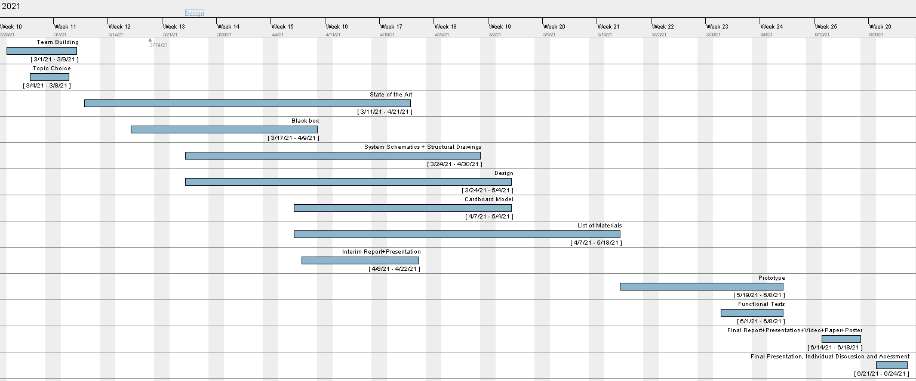
Release Gantt chart

